# Exercise: Flexbox - Photo Gallery

Create a web page like the following:

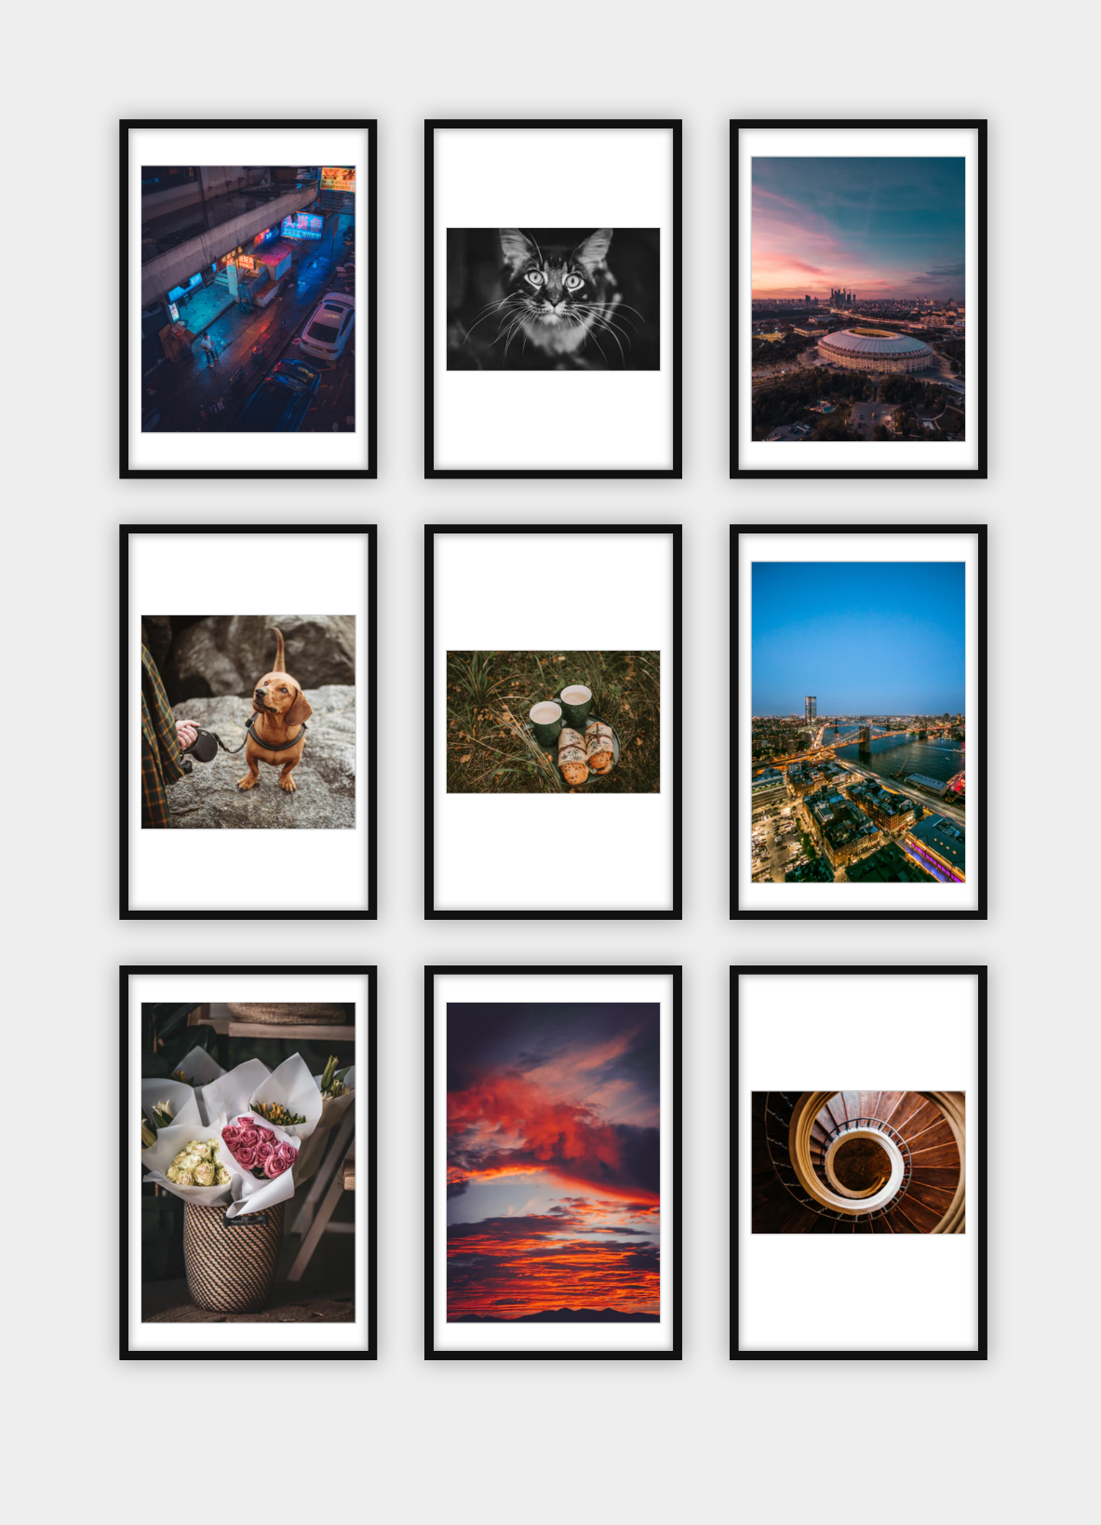

### Constraints

* Change the document title to "**Photo Gallery - Flexbox**"
* Add section with class gallery (section.gallery)
* Add unordered list with list items and images inside
* Change the body, ul and li display property to flex
* Use font Georgia, serifwith size 1em/1.2for the headings